How SQL Works?
SQL Porcessing flow
SQL Commands
Data query Language
SELECT * FROM table_name;

Data Manupulation Language
INSERT, UPDATE, DELETE

Data Defination Language
CREATE, ALTER, DROP

Data Control Language
GRANT, REVOKE

Transaction Control Language
COMMIT, ROLLBACK

Select all the field (Columns)
SELECT * FROM table_name;

Select only Few Field (Columns)
SELECT column1, column2 FROM table_name;

Show Column
SHOW COLUMNS FROM table_name;

ALTER TABLE
Add Column (ALTER TABLE ADD)
Delete Column (ALTER TABLE DROP COLUMN)
Insert Row (INSERT INTO VALUES)
Delete Row (DELETE FROM WHERE)
Update (UPDATE SET WHERE)
Drop Table (DROP TABLE)

Aggregate Function
- MIN()
- MAX()
- COUNT()
- AVERAGE()
- SUM()

Comparison Operators:
= Equal to
<> Not equal to
!= Not equal to
< Less than
> Greater than
<= Less than or equal to
>= Greater than or equal to

Logical Operators:
- AND Logical AND
- OR Logical OR
- NOT Logical NOT

Membership Operators:
- IN Checks if a value exists in a set of values
- NOT IN Checks if a value does not exist in a set of values

Between Operator:
- BETWEEN Checks if a value lies within a specified range
- Not BETWEEN Checks if a value lies within a specified range

IS NULL Operator:
- IS NULL Checks if a value is NULL
- IS NOT NULL Checks if a value is not NULL

EXISTS Operator:
- EXISTS Checks if a subquery returns any rows
- NOT EXISTS Opposite of Exists
LIKE Operator(WILDCARD):
- LIKE Matches patterns in strings using wildcard characters % and _

Concatenation Operator:
- || Concatenates two strings

Restricting with limit
LIMIT 3;

Use of Group By
GROUP BY Country;

Different Joints
Innter Join Innter Join
Left Join Left Join
Right Join Right Join
Outer Join Outer Join

ALTER TABLE
- Add Column (ALTER TABLE ADD)
- Delete Column (ALTER TABLE DROP COLUMN)
- Insert Row (INSERT INTO VALUES)
- Delete Row (DELETE FROM WHERE)
- Update (UPDATE SET WHERE)
- Drop Table (DROP TABLE)

Add Column
ALTER TABLE table_name
ADD column_name datatype;

Delete Column
ALTER TABLE table_name
DROP COLUMN column_name;

Insert Row
INSERT INTO table_name (CustomerName, City, Country)
VALUES ('Rajesh', 'Mumbai', 'India');

Delete Row
DELETE FROM Customers
WHERE CustomerName='Alfreds Futterkiste';

Update
UPDATE Customers
SET ContactName = 'Alfred Schmidt', City= 'Frankfurt'
WHERE CustomerID = 1;

Drop Table
DROP TABLE table_name;

AGGRETE Function
MIN()
SELECT MIN(Price) AS SmallestPrice
FROM Customers;

MAX()
SELECT MAX(Price) AS LargestPrice
FROM Customers;

COUNT()
SELECT COUNT(ProductID)
FROM Customers;

AVG()
SELECT AVG(Price)
FROM Customers;

SUM()
SELECT SUM(Quantity)
FROM Customers;

Filter the Data using Where and Comparision Operator

COMPARISON
SELECT * FROM Customers
WHERE Country='Mexico';

SELECT * FROM Customers
WHERE Country='Germany' AND City = 'Berlin';

COMPARISON AND LOGICAL OPERATOR
SELECT * FROM Customers
WHERE Country='Germany' AND (City='Berlin' OR City= 'Munchen');

NULL
SELECT * FROM Customers
WHERE Address IS NULL;

SELECT * FROM Customers
WHERE Address IS NOT NULL;

IN OPERATOR
SELECT * FROM Customers
WHERE Country IN ('Germany', 'France', 'UK')

BETWEEN
SELECT * FROM Products
WHERE Price BETWEEN 10 AND 20;

NOT BETWEEN
SELECT * FROM Products
WHERE Price NOT BETWEEN 10 AND 20;

WILDCARDS
Starting with "ber":
SELECT * FROM Customers
WHERE City LIKE 'ber%';

Ending with "ber":
SELECT * FROM Customers
WHERE City LIKE '%ber';

City containing the pattern "es"
SELECT * FROM Customers
WHERE City LIKE '%es%'

LIMIT
Simple Limit
SELECT Sale FROM Customers
LIMIT 3;

Limit with condition
SELECT Salary FROM Customers
WHERE Country='Germany'
LIMIT 3;

SORTING(Ordering of Table )
Sorting on Multiple Columns
SELECT * FROM Customers
ORDER BY Country, CustomerName;

Sorting on Multiple Columns
SELECT * FROM Customers
ORDER BY Country ASC, CustomerName DESC;

GROUP BY
The GROUP BY statement group’s rows that have the same values into summary rows, like "find the number of customers in each country".
The GROUP BY statement is often used with aggregate functions
COUNT(), MAX(), MIN(), SUM(), AVG() to group the result-set by one or more columns.

Group by on Single Table
SELECT COUNT(CustomerID), Country FROM Customers
GROUP BY Country;

JOIN
INNER JOIN
SELECT * FROM Orders
INNER JOIN Customers
ON Orders.CustomerID = Customers.CustomerID;

Join two table and then Group by
SELECT Shippers.ShipperName, COUNT(Orders.OrderID) AS NumberOfOrders
FROM Orders
LEFT JOIN Shippers ON Orders.ShipperID = Shippers.ShipperID
GROUP BY ShipperName;

DISTINCT : Returns Unique Value or Different Value
SELECT DISTINCT column1, column2, ...
FROM table_name;

UNION
Combines results of two or more SELECT statements, removing duplicates by default
By default, UNION removes duplicates between the two result sets.
SELECT column1, column2 FROM table1
UNION
SELECT column1, column2 FROM table2;

If you want to include duplicates, use UNION ALL:
SELECT city FROM customers
UNION ALL
SELECT city FROM suppliers;

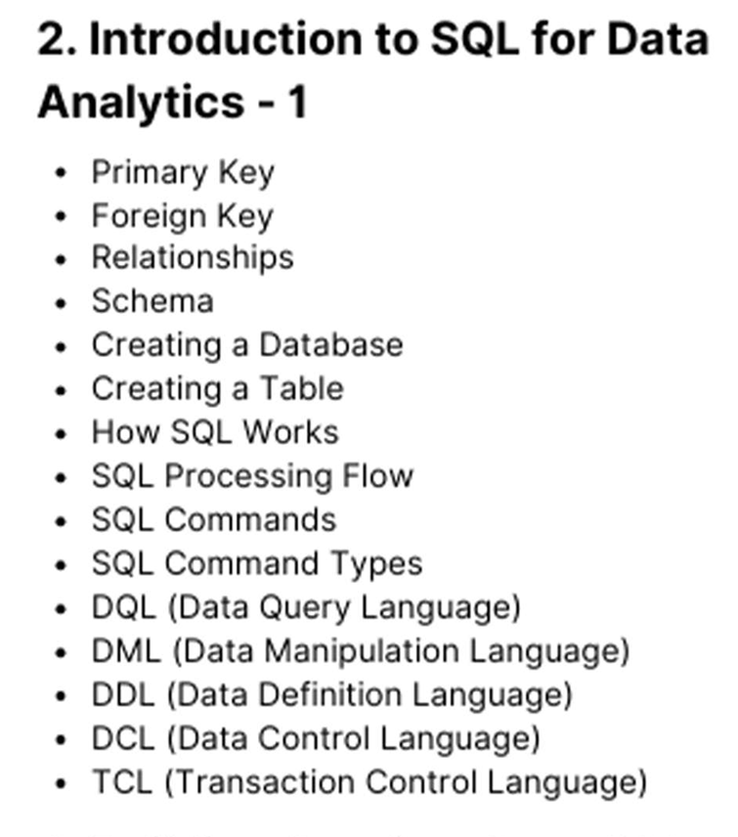

Primary Key

Foreign Key

Relationship

Schema

Creating Database

Creating TABLES

